01. Document details
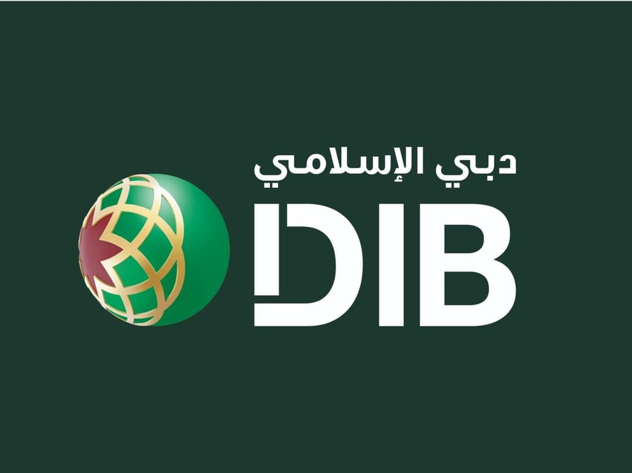

HFLMS
DDA Enhancements
  - DMGT-443
  - RUN THE BANK | KNOWLEDGE TRANSFER HANDOVER
Development team to RTB application support

Document attribute | Details
Application | Home Finance Loan Management System (HFLMS)
Change identifier | DMGT-443
Document type | Technical RTB KT handover
Version / date | 1.1 / 28 October 2026
Prepared by | Development Team | Sneha
Technical reviewer | Hariprasath | SME
Receiving audience | RTB application support team
Classification | Internal

Purpose
Provide RTB with the technical knowledge required to support DDA registration, cancellation, document handling, SOA/DDS integration, callback status updates and operational diagnosis.

02. Document index
Select a section title to navigate to the corresponding page.

01. Document details ................................ 1
02. Document index ................................ 2
03. Preparation, review and KT ownership ................................ 3
04. Technical change overview ................................ 4
05. Application and database components ................................ 5
06. DDA registration - technical flow ................................ 6
07. DDA registration - support queries ................................ 7
08. DDA cancellation - technical flow ................................ 8
09. DDA cancellation - support queries ................................ 9
10. RTB support and troubleshooting ................................ 10
11. Registration and Operations screens ................................ 11
12. Cancellation maker and checker screens ................................ 12
13. DDA Report and supporting documents ................................ 13

How to use this handover
Start with the relevant process flow, then use its matching support-query page. Follow the three technical checkpoints in order: document save, DDS submission and decision callback.
The final sections contain application screens for navigation during support.

03. Preparation, review and KT ownership

Preparation and technical review
Activity | Name / role | Date
Prepared by | Sneha | Developer | 27 October 2026
Technical review / approval | Hariprasath | SME | 27 October 2026
RTB KT edition | Development Team | 28 October 2026

KT and support ownership
Role | Contact | KT / support responsibility
Developer | Sneha | Application logic, integration mapping and defect analysis
SME | Hariprasath | Technical clarification and escalation coordination
Platform owner | Raheel | Application platform and service ownership
Scrum Master | Muni kumar | Delivery and team coordination
Product Owners | Aswathi, Talha | Business priority and product decisions
SP&BA | Basant | Process and business-analysis clarification
Requirement Owner | Shahzad | Requirement interpretation
Testers | Abhishek, Sathish | Scenario clarification and issue reproduction

Support handover approach
Development explains the application components, database touchpoints and integration checkpoints. RTB uses the queries and screen navigation in this handover to isolate issues and coordinate with HFLMS, SOA, DMS and DDS support.
User groups: Sales, Operations and CLM/SAM. Maker/checker controls and existing access permissions continue to apply.

04. Technical change overview

Change coverage
Technical area | Implementation / support detail
Registration and cancellation uploads | Signed-form upload at maker; document reference from Newgen/DMS; checker download and document override before onward submission.
Supporting documents | Additional uploads, including approval mails and Emirates ID; checker can view maker-uploaded supporting documents.
Registration routing | Sales and CLM/SAM request origin; separate CLM/SAM registration entry; conditional Operations bypass with skipped-stage audit history.
Draft handling | Generate saves a draft. Retrieval returns draft values when present; Cancel Draft removes the drafted version.
Identifiers | Application IDs retain hyphens during DDA registration.
Status, remarks and notification | CBUAE approval/rejection returns via DDS/SOA. HFLMS status and remarks are reflected in DDA Report; action/outcome notifications target the initiator and Operations.

Registration routing parameters
Installment validation uses IBAN, Emirates ID and customer name. Property Takaful also uses minimum/maximum amount, recovery type and annual repayment frequency. Fixed recovery requires equal minimum and maximum amounts.

Cancellation integration behaviour
Cancellation sends Capture_Mode = 'M'. The parameter is maintained through FRM_GNARR and the existing System Parameter interface. This is an integration dependency; do not change it during callback or status troubleshooting without approved change control.
Document-save success and a DMS reference do not, on their own, establish that a document was attached to the outbound DDS request. Trace the cancellation request and response independently of the upload step.

05. Application and database components

Application components
Technical surface | Components
Registration | w_dda_resgistration.aspx  w_dda_resgistration.aspx.cs  DDA_Registration.js
Registration checker | DDARequest_For_Approve.aspx  DDARequest_For_Approve.aspx.cs
Cancellation maker | DDACancalalelationForm.aspx  DDACancalalelationForm.aspx.cs
Cancellation checker | dw_dda_cancellation_for_approval_ops.aspx  dw_dda_cancellation_for_approval_ops.aspx.cs
Document views (new) | DDA_UploadDocument_List.aspx  DDA_UploadDocument_List.aspx.cs  DDA_ViewDocumentList.aspx  DDA_ViewDocumentList.aspx.cs
History and reporting | DDA_Movement_History.aspx  DDA_Movement_History.aspx.cs  DDA_Report.aspx
Integration | DDACallbackService.asmx.cs  SOACoreBanking.cs

Database components
Component | RTB technical touchpoint
PROC_DDA_SEND_EMAIL (new) | DDA email notification processing
PROC_DDA_DisplayDetails; PROC_DDA_CORE;  DDA_TEMP_REG; DDA_REG_CANC_SYNC_To_HFLMS | Database change components for DDA processing
CORE_DDA_Registration_DETAILS | Registration status and department lookup
CORE_DDA_CANCELLATION_DETAILS | Cancellation record lookup
SOA_Calllog_core | Integration calls by method_name, lead_no and Createdon_date

06. DDA registration - technical flow
Trace the registration using the same application/DDA reference and a consistent incident time window across HFLMS, DMS, SOA and DDS.
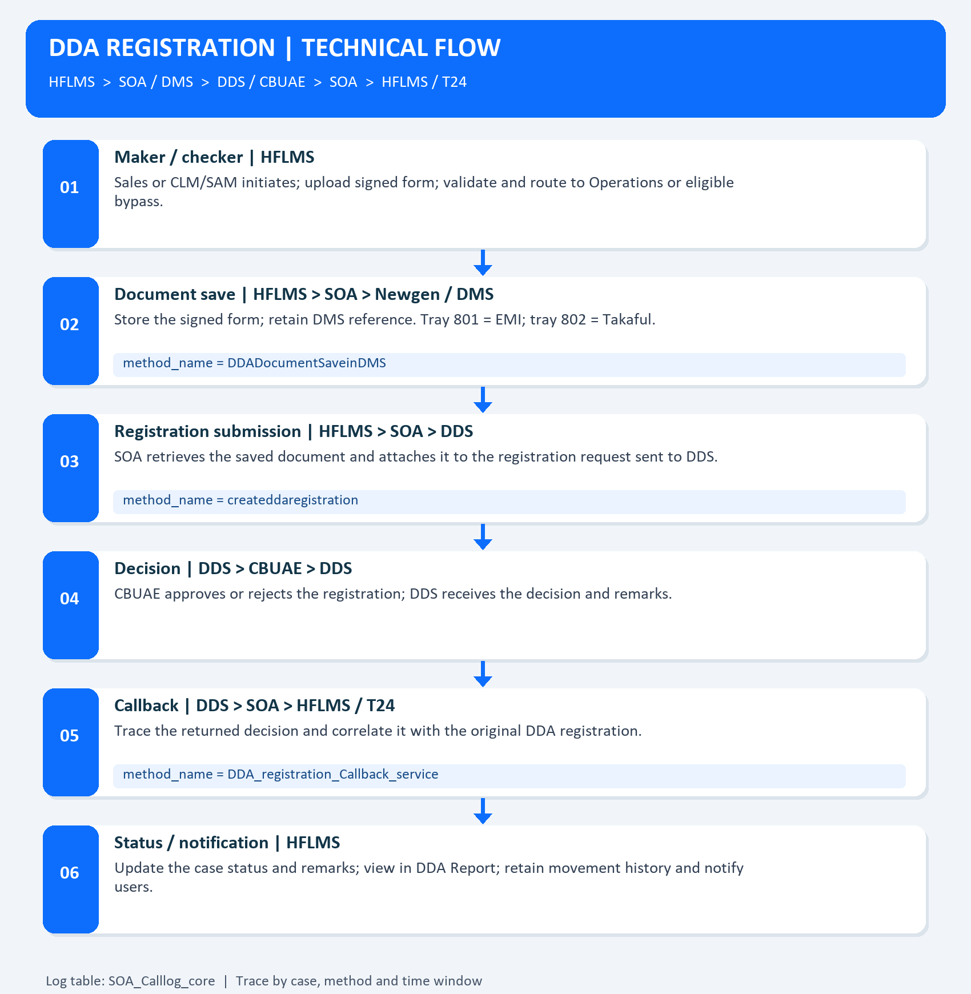
Registration flow: document save, DDS submission, CBUAE decision and callback/status update.

07. DDA registration - support queries
Run the following read-only batch through the approved database access tool. Replace MFXXX and the example timestamps with the required application and incident window. Times must use the database log timezone.
DECLARE @ApplicationId varchar(50) = 'MFXXX';
DECLARE @StartTime datetime = '2026-10-27T00:00:00';
DECLARE @EndTime datetime = '2026-10-28T00:00:00';
-- Application registration status
SELECT DDS_STATUS, DEPARTMENT
FROM CORE_DDA_Registration_DETAILS
WHERE APPLICATIONID = @ApplicationId;
-- 1. Document save: DMS trays 801 / 802
SELECT lead_no, method_name, Createdon_date
FROM SOA_Calllog_core
WHERE UPPER(method_name) = 'DDADOCUMENTSAVEINDMS'
AND Createdon_date >= @StartTime
AND Createdon_date < @EndTime
ORDER BY Createdon_date;
-- 2. Registration request to DDS
SELECT lead_no, method_name, Createdon_date
FROM SOA_Calllog_core
WHERE UPPER(method_name) = 'CREATEDDAREGISTRATION'
AND Createdon_date >= @StartTime
AND Createdon_date < @EndTime
ORDER BY Createdon_date;
-- 3. Registration decision callback
SELECT lead_no, method_name, Createdon_date
FROM SOA_Calllog_core
WHERE UPPER(method_name) = 'DDA_REGISTRATION_CALLBACK_SERVICE'
AND Createdon_date >= @StartTime
AND Createdon_date < @EndTime
ORDER BY Createdon_date;

Reading the results
The application lookup is case-specific. Log queries return all calls for the selected method/window. Identify the correct lead_no through the request correlation; do not assume lead_no equals APPLICATIONID. After confirming the mapping, add AND lead_no = '<confirmed_lead_no>' to each log query.
Check the DMS reference, outbound registration response, callback response and final DDS_STATUS/DEPARTMENT. Use DDA Report and movement history to follow the same case.

08. DDA cancellation - technical flow
Trace cancellation as a separate process. Document upload, DDS submission and callback/status propagation are distinct support checkpoints.
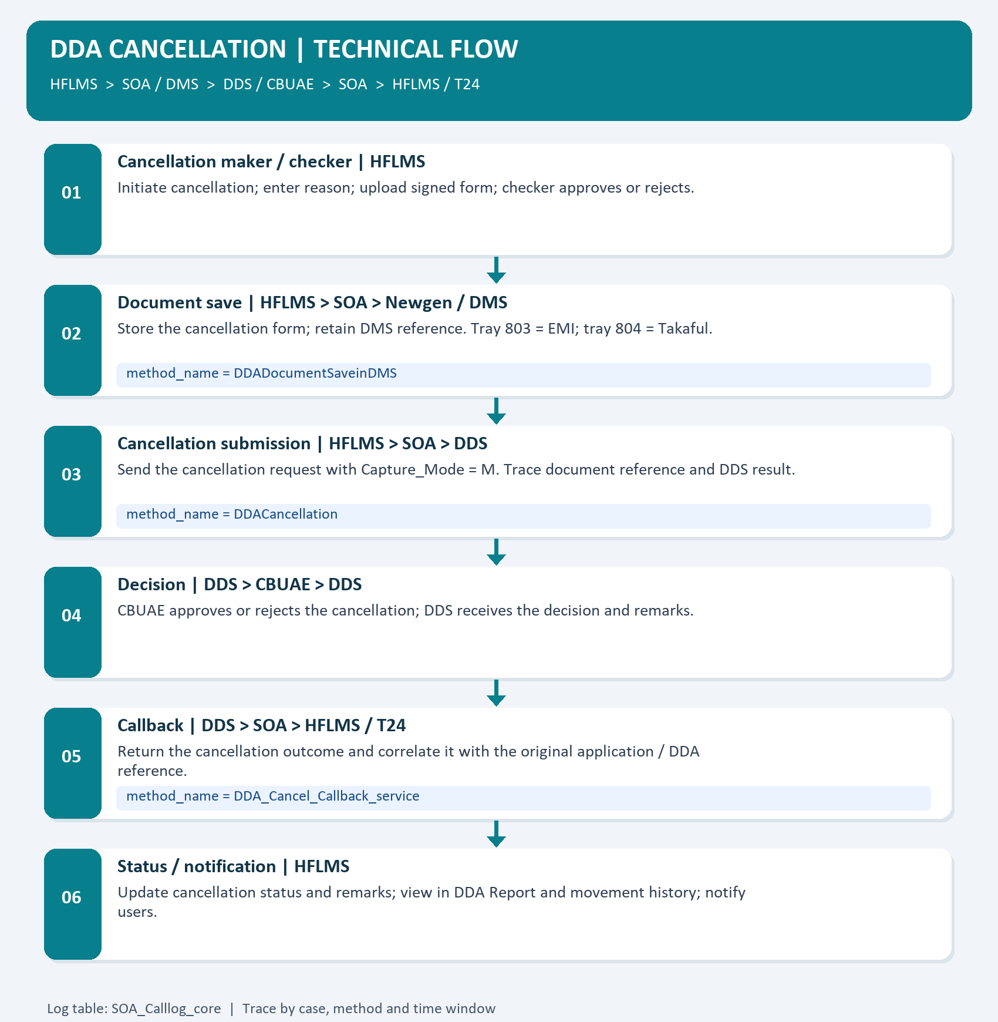
Cancellation flow: document save, Capture_Mode M request, CBUAE decision and cancellation callback.

09. DDA cancellation - support queries
Run the following read-only batch through the approved database access tool. Replace MFXXX and the example timestamps with the required application and incident window. Times must use the database log timezone.
DECLARE @ApplicationId varchar(50) = 'MFXXX';
DECLARE @StartTime datetime = '2026-10-27T00:00:00';
DECLARE @EndTime datetime = '2026-10-28T00:00:00';
-- Application cancellation details
SELECT *
FROM CORE_DDA_CANCELLATION_DETAILS
WHERE APPLICATIONID = @ApplicationId;
-- 1. Document save: DMS trays 803 / 804
SELECT lead_no, method_name, Createdon_date
FROM SOA_Calllog_core
WHERE UPPER(method_name) = 'DDADOCUMENTSAVEINDMS'
AND Createdon_date >= @StartTime
AND Createdon_date < @EndTime
ORDER BY Createdon_date;
-- 2. Cancellation request to DDS
SELECT lead_no, method_name, Createdon_date
FROM SOA_Calllog_core
WHERE UPPER(method_name) = 'DDACANCELLATION'
AND Createdon_date >= @StartTime
AND Createdon_date < @EndTime
ORDER BY Createdon_date;
-- 3. Cancellation decision callback
SELECT lead_no, method_name, Createdon_date
FROM SOA_Calllog_core
WHERE UPPER(method_name) = 'DDA_CANCEL_CALLBACK_SERVICE'
AND Createdon_date >= @StartTime
AND Createdon_date < @EndTime
ORDER BY Createdon_date;

Reading the results
The application lookup is case-specific. Log queries return all calls for the selected method/window. Identify the correct lead_no through the request correlation; do not assume lead_no equals APPLICATIONID. After confirming the mapping, add AND lead_no = '<confirmed_lead_no>' to each log query.
Use the cancellation record to inspect status and remarks. SELECT * is restricted to the selected application so the actual deployed column names are returned. Check the DDS result and callback before treating a stale report status as a failed cancellation.

10. RTB support and troubleshooting

Cancellation parameter lookup
SELECT DisplayValue
FROM FRM_GNARR
WHERE value = 'DDA_CANCELLATION_CAPTURE_MODE';
Expected operational value: M. Inspect the outbound DDACancellation request for <Capture_Mode>M</Capture_Mode> when diagnosing request mapping. Use the existing System Parameter interface and approved change control for parameter changes.

Operational triage
Issue | Technical checks and support action
Form cannot be retrieved | Confirm application and document version; inspect DDADocumentSaveinDMS. Check DMS reference and correct tray: registration 801/802; cancellation 803/804. Coordinate with SOA/DMS support.
DDS submission missing / rejected | Inspect createddaregistration or DDACancellation within the incident window. Correlate the outbound request, document reference, DDS response and CBUAE remarks with SOA/DDS support.
CBUAE decision received; HFLMS stale | Inspect the matching callback method and response. Check application persistence, DDA Report status/remarks and movement history. Coordinate with the HFLMS SME and SOA/DDS support; reconcile the T24 outcome with its support team.
Document override / draft issue | Check maker upload and checker-selected file; confirm latest document in report. For drafts, check retrieval and Cancel Draft behaviour against the affected application.
Notification not received | Check the action/outcome, initiator and Operations recipients. Ask DBA/application support to trace PROC_DDA_SEND_EMAIL and coordinate with the mail service team.

Safe support practice
Use read-only queries for initial diagnosis. Capture application ID, DDA/reference number, correlated lead_no, DMS reference/tray, method name, timestamps and DDS/CBUAE outcome in the incident record.
Do not manually overwrite statuses, delete DDA records or resend an instruction solely because the screen is stale. Coordinate correction or replay with the application/integration owners under approved incident and change procedures.

11. Registration and Operations screens

Registration maker and Operations screens
Use these screens to locate the signed form, maker actions, approval/rejection controls and document access.
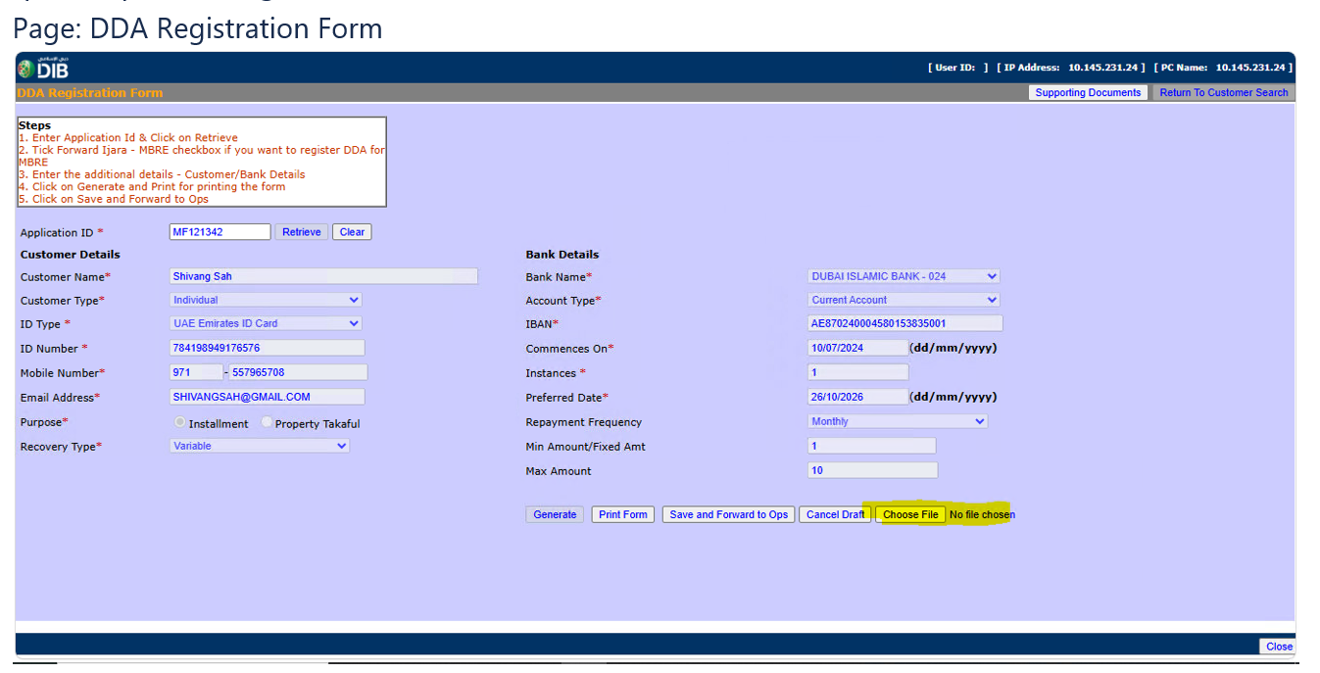
DDA Registration Form - signed-form selection and maker actions.
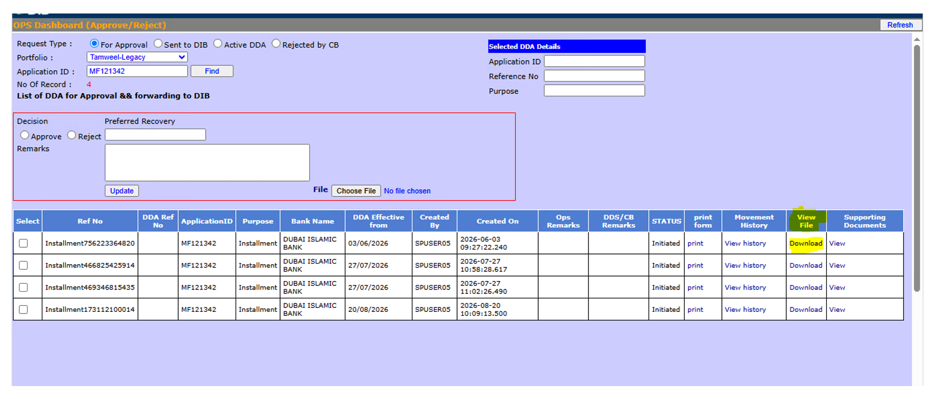
Operations registration dashboard - approve/reject, remarks, uploaded form and supporting-document access.

12. Cancellation maker and checker screens

Cancellation maker and Operations checker
Use application retrieval and the cancellation reason on the maker screen; use the checker dashboard for approval/rejection and form download.
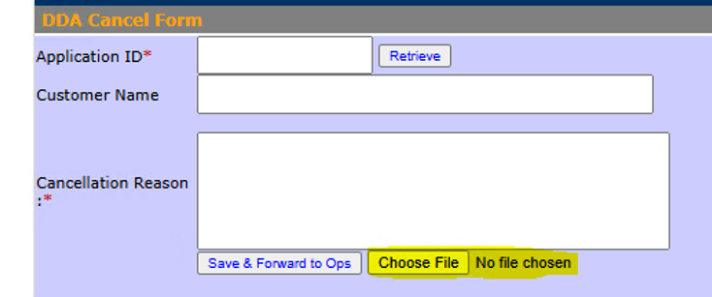
DDA Cancellation Form - application retrieval, cancellation reason and signed-form upload.
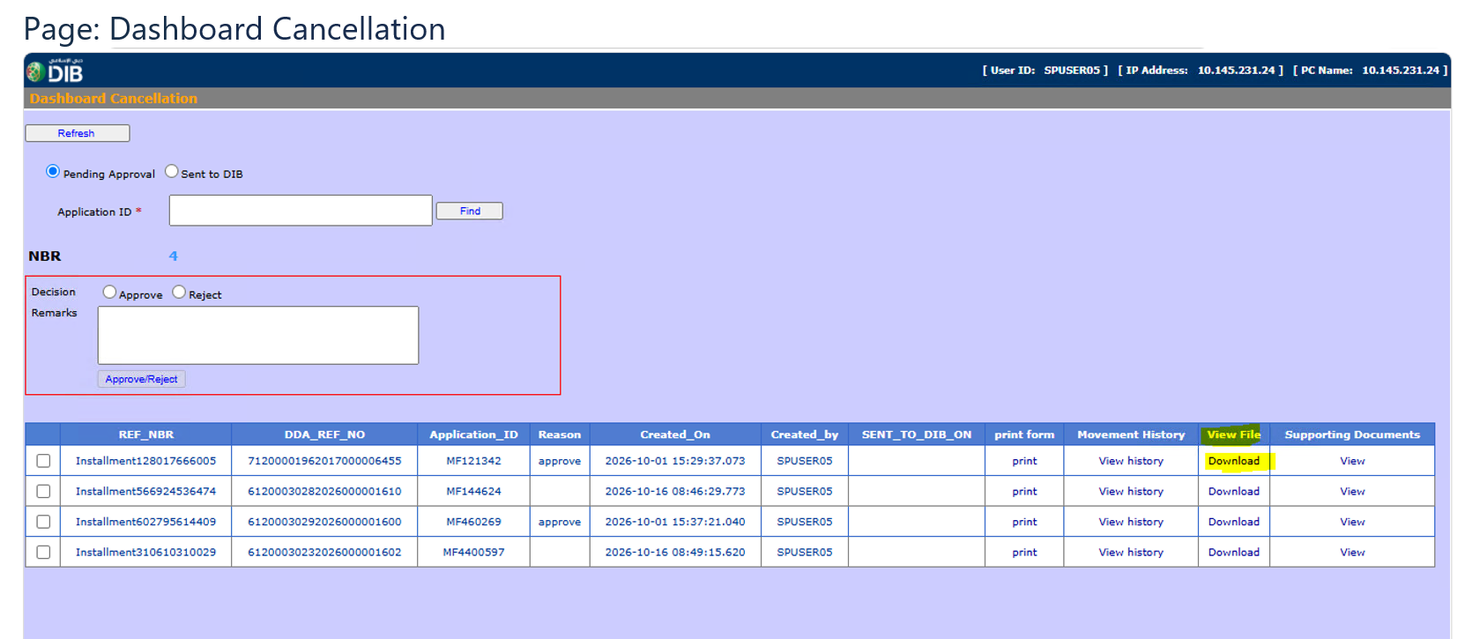
Cancellation dashboard - checker actions, remarks and uploaded-form access.

13. DDA Report and supporting documents

Reporting and document navigation
Use DDA Report to inspect the case status/remarks and latest uploaded form. Use Supporting Documents to manage additional case documents under existing access controls.
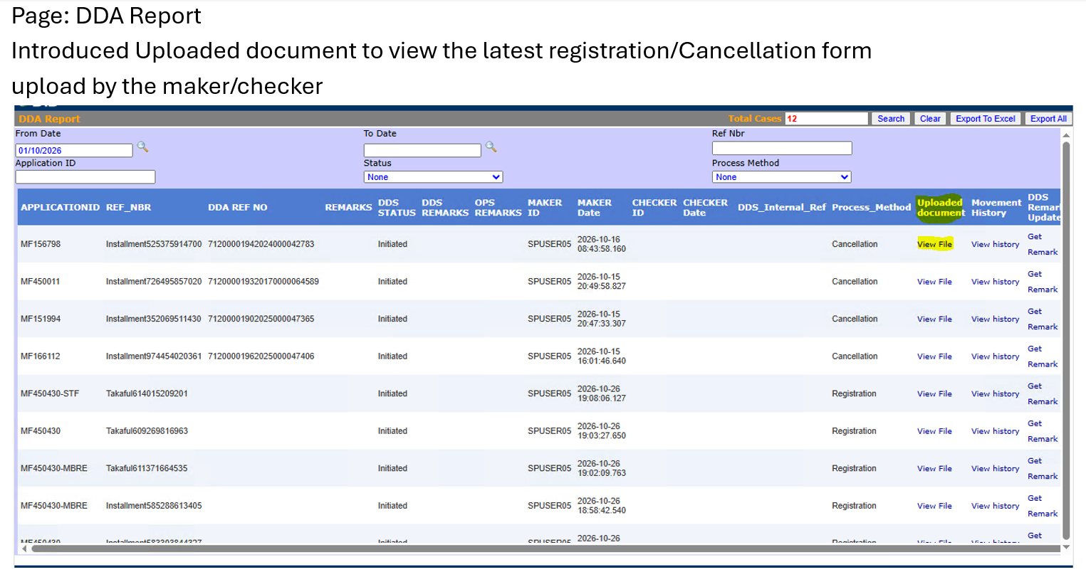
DDA Report - DDS status/remarks, uploaded document and movement history.
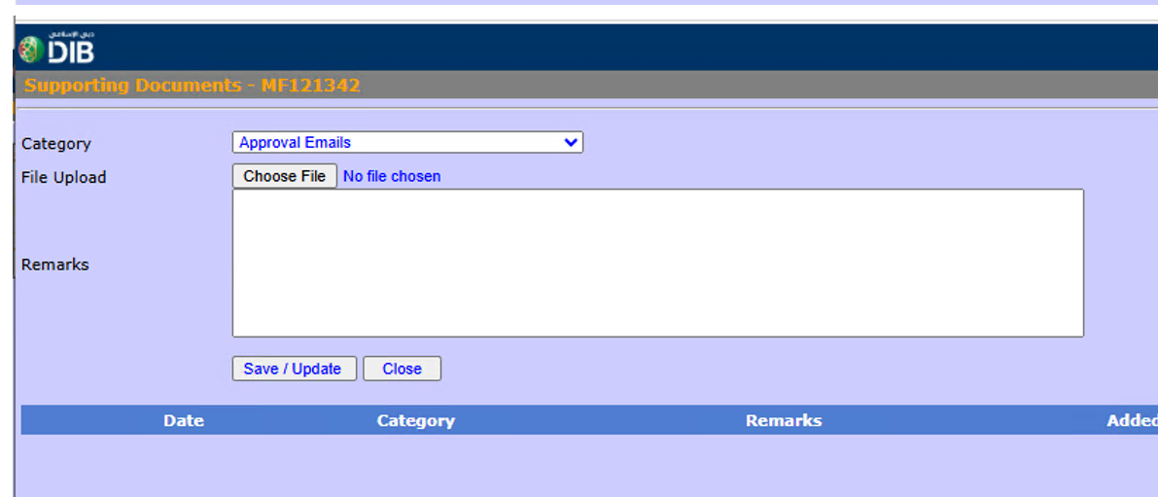
Supporting Documents - category, file selection, remarks and Save/Update.

